REST API DESIGN

For using REST, using json -server mock data server. It run in the default port number 3000.The user data is passed as an array for now, because currently have no database . For Security use JWT authentication for login , it will give a secure token with an expiry time .

Here the server is in port number 4000 ,to check the server is running , first need to run “node index.js ” in server folder if all fine , it will display the message as,

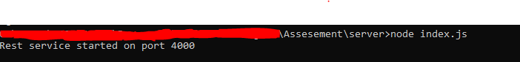

The main api are ,

1. <http://localhost:4000/login>

this api is used for login , This is a Post Request, the request format is,

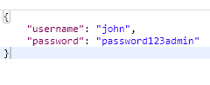

If the server is running correct, it will give the response as a token

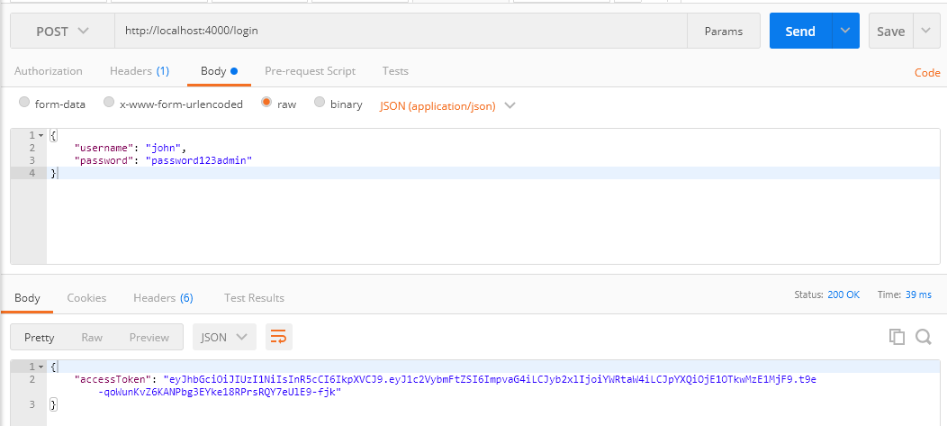

1. <http://localhost:4000/campaigns>

To get all campaign list can call this api , it is GET request

